LABORATORY WORK #5.1

WORKING WITH DATABASES
MS ACCESS

Microsoft Access is a Relational Database Management System (RDBMS), designed primarily for home or small business usage.
Access has traditionally been known as a desktop database system because its functions are intended to be run from a single computer (as opposed to a server database application where the application is installed on a server, then accessed remotely from multiple client machines).
Having said this, Microsoft Access has included a web solution (as well as its desktop solution) since 2010, where it is integrated with SharePoint and, since 2013, SQL Server.
Microsoft Access (or MS Access) is a software package that you install just like any other software package, and is bundled as part of the Microsoft Office suite.

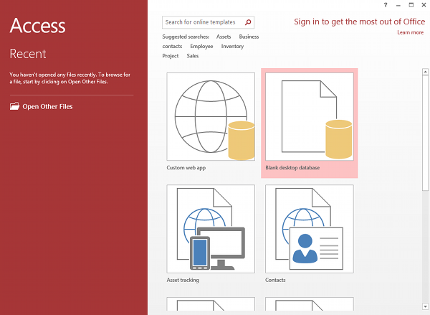

Picture 1 - MS Access 2013: Creating a new database in Access

For this tutorial, we're going to create a database for a ficticious company called "Space Trips". This company sells space ships! Space Trips' customers are the adventurous type who like to make their own travel arrangements thank you very much. They prefer the "self-fly" holidays when they visit other planets. So they come to Space Trips whenever they need to purchase a new space ship.
Business is booming and the company now needs a database to keep track of their customers and the products they purchase. That's where we come in. Let's use Microsoft Access 2013 to create a database just for their needs.

1.1 Create the Database

The first step to creating a database is to, well, create the database! We will create a blank database first. Then throughout the rest of the tutorial, we'll make additions to it so that it suits the needs of our favorite space travel company.
Creating a database in Microsoft Access is as easy as creating a Word document! This lesson demonstrates how to create a database in MS Access.
- You may notice that, when you first start Microsoft Access 2013, you see the following screen (Picture 1). In this case, you can simply select Blank desktop database (then skip to Step 3).
- Choose Blank desktop database.
- Choose a name and click Create. Let's call it SpaceTrips. You can either use the default location or click the folder icon to change the location.
Once you've completed the above steps, you should see a blank database.
We know this database is blank because it only contains one table (called Table1) and that table only has one column (called ID). So we need to add some more columns to the table and give the table a name.

1.2 Create a Table

With database management systems, you need to create your tables before you can enter data. Microsoft Access makes creating tables extremely easy. In fact, when you create a database, Access creates your first table for you (and calls it Table1).
Normally when you need to create a new table, you'll select CREATE > Table from the Ribbon toolbar. But we can do that later.
For now Access has already created our first table, so all we need to do is modify that table so that it suits our needs.
Using our blank database, we are going to rename Table1 to Customers. This table will have 4 columns: CustomerId, FirstName, LastName, and DateCreated.
- Rename the ID field to CustomerId. To do this, Right-click on the ID column and select Rename Field. Enter CustomerId when prompted.
- On the next field, click on Click to Add (unless Access has already opened the menu for you) and select Short Text.
- At this point, Access will conveniently highlight/select the field name (currently Field1) so that you can name the field. Call it FirstName.
- Do the same again for the next field (LastName) and select data type Short Text.
- In the next field, select the Date & Time data type and name the field DateCreated.
What we just did was create the column names and specify the type of data that can be entered into them. Restricting the data type for each column is very important and helps maintain data integrity. It can ensure that the user enters the data in the intended format. It can also guard against accidents like for example, inadvertently entering an email address into a field for storing the current date.
Your database table should now look like Picture 2.
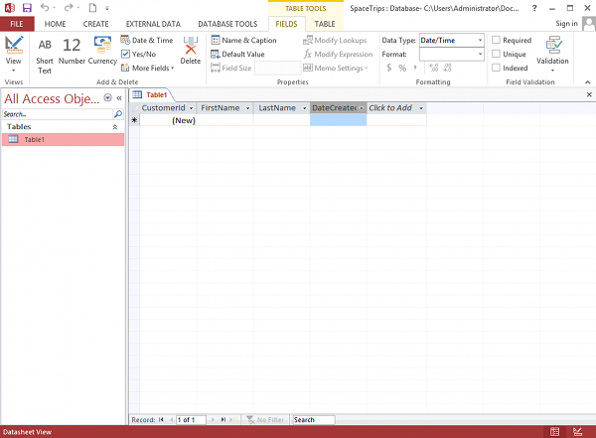

Picture 2 - Creating a database table in MS Access 2013

You might notice that now when you click on the field names, you can't see or change their data types. Instead, if you click on the inverted triangle within a field, you see a different menu of options (eg, Sort Oldest to Newest etc) depending on the field's data type. This shows that the field is ready for data - once you have data, you can sort it using this menu.
Don't worry if you accidentally entered the wrong data type. You can change the dataype in the Ribbon toolbar by adjusting the data type under the Data Type dropdown (top right area of the toolbar). If you can't see this option in the toolbar be sure to select the FIELDS tab first.

1.3 Design View

We have just created a database table. We did this in Datasheet view. Next we will see how it appears in Design view.
Design view enables you to design and set up your database (kind of a "behind the scenes" view of your database). This is where you set up and configure your tables, forms, reports, etc.
As you continue working with MS Access, you will find yourself switching between Design view and Datasheet view (or in the case of forms, Layout view) often. So it's good to familiarize yourself with this concept early on.
The following steps demonstrate how to switch to Design view.
- Click on the View icon at the top left (just under the File menu). The View icon currently looks like this: 
- At this point, Access will ask you to name and save the table you just created. Type Customers and click OK.
- You are now looking at your Customers table in Design view. Click on the DateCreated field, then in the bottom pane, enter =Now() in the Default Value field. Also click in the Format field and select General Date from the contextual menu (Picture 3).
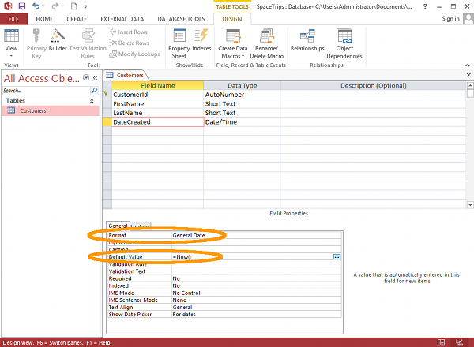

Picture 3 - Screenshot of Design view

We have just set a default value for the DateCreated field. This means that, whenever a new record is entered, this field will automatically be populated with the current date and time. We have also specified a format for all dates that are stored in this field.
You can see that we have configured just two of many options in this pane. These options can be used to further specify exactly what type of data can be entered into the database as well as any constraints or defaults that you'd like to set against each field. Some options include restricting the length of data (under Field Size), setting a default value (which we've just done), specifying whether it is a required field, and more.
In practice, you will probably want to tighten some of these rules down - like specifying whether a field is a required field or not (i.e. can't be left blank). But for the purposes of this tutorial, we won't get too fussy.
You'll also see that the Ribbon now has a DESIGN tab with a new set of design-related options.
You might have noticed the little "key" icon to the left of the CustomerId field. This indicates that the field is a primary key. A primary key ensures that the data in this column is unique - no two values can be the same. This is important for when you want to perform queries or run reports against the table, and it is vital for establishing relationships with other tables.
You can also click on the little ... button that appears whenever you click in the Default Value field (and other fields too). Clicking on this button opens the Expression Builder, which enables you to browse for a suitable function, constant, or operator to assist you in building an expression for the field.
We could just have easily used the Expression Builder to build our =Now() expression.
Now that we're in Design view, you might have noticed that the View icon looks different - it has changed from a Design view icon into a Datasheet view icon. It now looks like this: 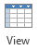
Click the View icon to return to Datasheet view, and we'll look at the options for adding data to our table.

1.4 Adding Data

In Microsoft Access, there are many ways to add data to your database. Which method you choose will depend largely on how much data you need to add and whether the data already exists outside of Access.
Here's an explanation of the main methods of adding data to a database.
- Datasheet View. You can type directly into the table while it's in Datasheet view. While this is fine for smaller tables with a small number of records that are rarely updated, it's not suitable if you plan to maintain a lot of records. Maintaining even a small database can become a time-consuming task if records change frequently - especially if you need to update data that's spread across multiple tables. It's also not really suitable if there will be non-technical users maintaining the database. For non-technical users, it's better to create a nice user-friendly form.
- Form. You can set up a form, so that non-technical users can enter data into the form. Once they submit the form, the data is automatically inserted into the database. One of the great things about forms is that they can insert into many tables - saving you from having to open up each table to manually insert the data.
- SQL View. You can use SQL view to insert data into your database. You can also use SQL view to do many other things with your database (including creating tables). SQL (which stands for Structured Query Language) is the standard programming language for working with databases. To select SQL View from the Ribbon, select CREATE > Query Design, (close the popup table - called Show Table), then select SQL View.
- External Data. There may be times when you need to load your database with data that already exists. For example, you might have data in an Excel spreadsheet or even a .csv file that you want to transfer to an Access database. This can be done!

1.5 Establish the Relationship

A primary feature of relational databases is that they contain multiple tables, each of which can have a relationship with any of the other tables. So far we've only created one table and it's a bit difficult trying to establish a relationship with another table when you're the only table in the database!
Our database needs more than one table anyway, because we need to be able to track not only customers, but also products, as well as the products the customers actually purchase.
So let's create two more tables and establish a relationship between them. One table will hold product information, the other will hold order information.
Go ahead and create two tables as follows.

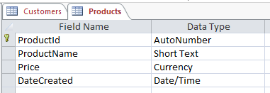

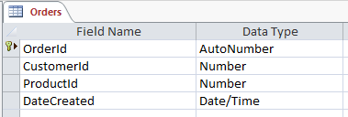

Be sure to set a format and default value for the DateCreated fields on both tables (the user shouldn't need to enter this field - the system can do that).
Remember that the key icon indicates that the field is a primary key. A primary key ensures that the data in this field is unique - no two values can be the same. A table must have a primary key before a relationship can be established with another table. Access automatically sets the ID field as a primary key, so as long as you simply rename ID to ProductId (or OrderId as the case may be) it will already be a primary key. If for some reason your table doesn't have a primary key set, or if you want to change the primary key field, you can simply right click on the field header (in Design view), and select Primary Key from the contextual menu.
Now that you've created two extra tables, our database has three tables. Now it's time to create the relationship between all three tables.
- While viewing a table in Design view, and ensuring that the DESIGN tab is selected, click Relationships from the Ribbon:

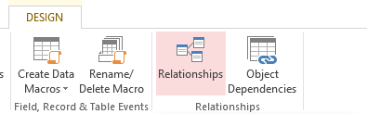

- A Show Table dialog box will pop up, displaying all three tables. Select all of them and click Add:

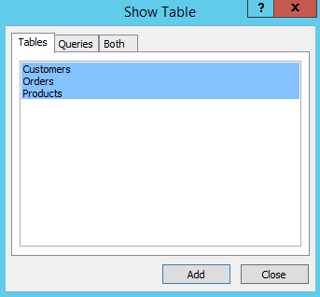

- Click Close to close the dialog box.
- You will now see three boxes which represent your three tables. Click and drag the CustomerId from the Customers table across to the corresponding CustomerId field on the Orders table:
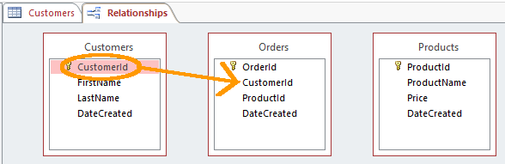
- The Edit Relationships dialog will pop up. Click Enforce Referential Integrity so that it is checked. Check that the values are the same as the following screenshot and click OK:
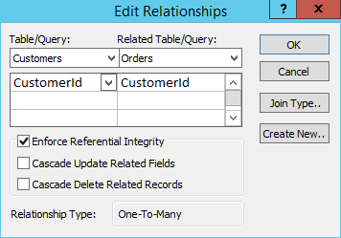
You will now see a line established between the CustomerId field on the Customers table and the CustomerId on the Orders table.
- Now do the same for the Products table. That is, click and drag the ProductId from the Products table across to the corresponding ProductId field on the Orders table. Your table relationships should look like the ones in the following screenshot:
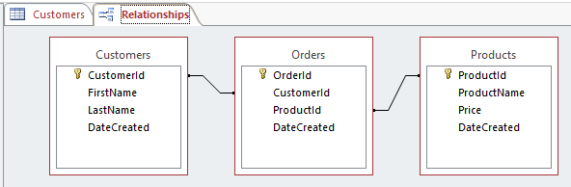

1.6 Relationship Types

We just established a many-to-many relationship. There are three types of relationships that you can establish between tables. These are as follows:

Many-To-Many Relationship. This is what our example above uses. A row in table A can have many matching rows in table B, and vice versa. In our case, a single customer can order many products, and a single product could have many customers. You create a many-to-many relationship by using a third table, called a junction table (more on that below).
One-To-Many Relationship. This is the most common relationship type. You don't need a third (junction) table for this type of relationship. In this type of relationship, a row in table A can have many matching rows in table B, but a row in table B can have only one matching row in table A. For example, a row in a Gender table (which contains the records Male and Female) can have many matching rows in a Customers table, but a row in the Customers table can only have one matching row in the Gender table. That is unless there was a business rule that allowed customers to be male and female at the same time. In this case, a many-to-many relationship would need to be established.
One-To-One Relationship. A row in table A can have only one matching row in table B, and vice versa. This is not a common relationship type, as the data in table B could just have easily been in table A. This relationship type is generally only used for security purposes, or to divide a large table, and perhaps a few other reasons.
The type of relationship that you use depends on the table structure and how the fields are defined.
In the above relationship, the Orders table is known as a junction table. A junction table is one that contains common fields from two or more other tables within the same database. It is used as a reference table in a many-to-many relationship (such as we are doing in our example).
Junction tables are known under many different names. Here are some: cross-reference table, bridge table, join table, map table, intersection table, linking table, many-to-many resolver, link table, pairing table, pivot table, transition table, or association table.
So if you ever hear someone mention one of those, you should have some idea what they are referring to.
We already know that a primary key ensures that the data in the field is unique. This is important because our Orders table needs a unique value in order to reference any record from the other tables. For example, it can't use the FirstName field because there could be more than one person with a given first name. And it can't use the DateCreated value because it's possible that two records could be created at exactly the same time (eg, if two operators are entering data or if many records are imported from an external source). This is why we need at least one field that we know will only ever contain a unique value.
A foreign key is simply the primary key's corresponding field in the related table. So in our example, the CustomerId field in the Orders table is a foreign key, while the CustomerId field in the Customers table is a primary key. Likewise, the ProductId field in the Orders table is a foreign key, while the ProductId field in the Products table is a primary key. The fields don't necessarily need to have the same names but it's a good practice to get used to. It will definitely make the database structure easier to understand - especially when you start adding more tables that also need to have relationships established.
Creating relationships like the one above can assist in building queries against the database.

1.7 Create a Query

A query refers to the action of instructing the database to return some (or all) of the data in your database. In other words, you are "querying" the database for some data that matches a given criteria. The queries are run against one or more tables to return only the data that you're interested in.
For example, you might like to see a list of all individuals whose last name is "Griffin". Or you might like to see a list of all users who have registered with your database over a given time period. You might also want to see which customers have ordered a particular product. To do all this, you need to perform a query.
Before we start querying the database, we should probably make sure we've got enough data in there first. Otherwise it doesn't matter how good our queries are - they will all return zero results if there's zero data. So let's add some data.
Remember, the ID columns and DateCreated columns are automatically generated, so you only need to enter data into two columns in each table.
Feel free to make up your own data.
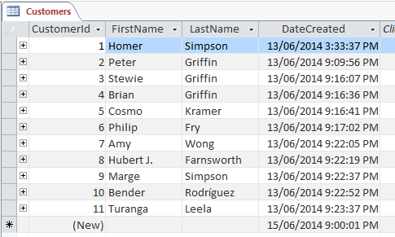
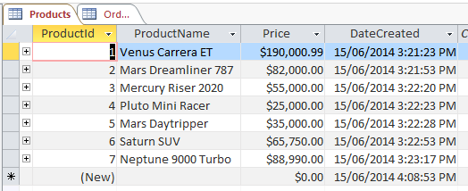
Again, feel free to make up your own but you will need to make sure that the value in the CustomerId and ProductId fields match an actual ID in the respective tables. For example, if your Orders table contains a CustomerId of 5, you will need to make sure there's an actual customer in the Customer table with a CustomerId of 5. Here's some sample data for the Orders table:
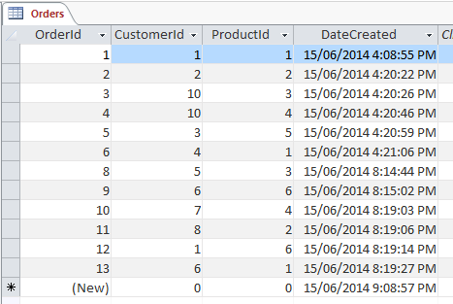

When you create a relationship, you also have the option to Enforce Referential Integrity (which we selected when we created our relationship). This prevents foreign key values from having no corresponding primary key value in the referenced table.
Using our tables as an example, let's say you have 10 records in the Customers table (with a CustomerId of 1 to 10), but your Orders table contains a record using a CustomerId of 11. In this case, referential integrity has not been maintained. If you had enforced referential integrity on the relationship (as we have), Access would prevent this from happening.
Now let's create a query that returns the names of all customers who have ordered a product.
- Ensuring you have the CREATE tab open on the Ribbon, click Query Design.
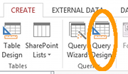

- The Show Table dialog box will appear with all of our tables listed. Select all three tables and click Add, then click Close:
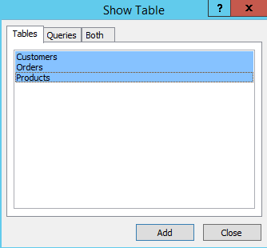

- The three tables are now represented in the top pane (beneath the Ribbon). Choose the fields you'd like to be presented in the results of your query. You can either double click on the field name or click and drag it down to a column in the bottom pane. Select the fields as follows:
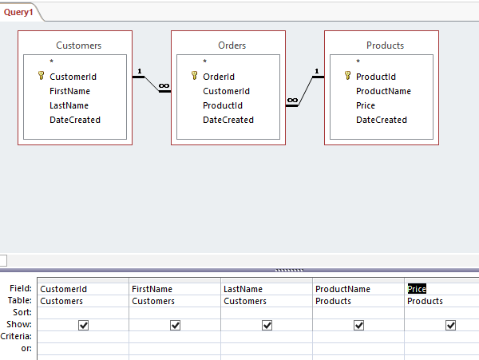

- Click the Run button at the top-left part of the Ribbon:
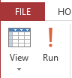
- You should now see the result of the query.
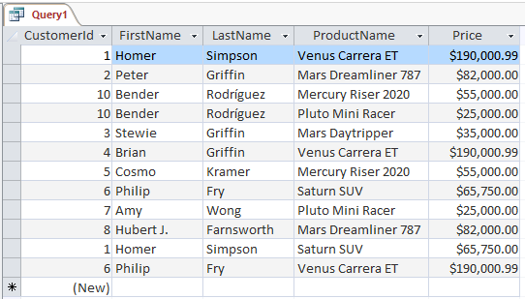
- Save the query by right-clicking on the Query1 tab and giving it a name. Call it Customer Orders:
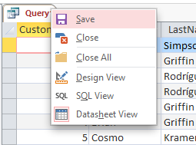
Our query successfully returns a all customers who ordered at least one product and it includes the product and its price next to their name. You can also see that some customers have ordered more than one product. The query has automatically joined the three tables using the relationship that we created and returned the matching data.
This query will only return those customers who have ordered at least one product. If a customer is in the Customers table but does not order a product, that customer's record will not be displayed in the results of this query. If you look back at the Customers table (near the top of this page), you'll see that Marge Simpson is a customer but she hasn't ordered any products yet (i.e. she doesn't have a corresponding record in the Orders table). Well actually, Marge is only a potential customer. She simply expressed interest in buying a space ship. But that didn't stop the pesky sales person from adding her name into the database!
In any case, the query has done its job. We didn't want to see a big list of customers that haven't ordered anything yet.
Next we're going to modify our query so we can look at some of the other things we can do with queries.

1.8 Modify a Query

OK so we just created a query to return all customers in our database who have ordered a product. Now we'll see if we can tweak the query a little bit here and there to see what other results we can return.
The marketing department wants to see who, if anyone, ordered their most expensive space ship. So, let's return a list of all customers who purchased the most expensive space ship - the "Venus Carrera ET".
- From Design view, in the bottom pane, enter "Venus Carrera ET" (double quotes included) into the Criteria field of the ProductName field:
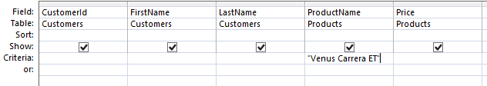
- Click the Run button in the Ribbon to view the results of the query. Alternatively, you can just click the Datasheet View icon. And here's the result:

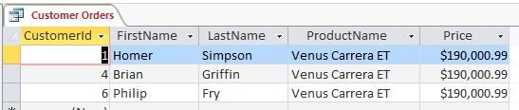
- Once you're satisfied with the results, return to Design view and remove your modification (i.e. remove "Venus Carrera ET" from the Criteria field).
You could also modify your query so that it returns customers who purchased a product worth over a certain price.
So let's construct a query that returns all customers who purchased any product with a price over $80,000.
- From Design view, in the bottom pane, add (>80000) into the Criteria field of the Price field:
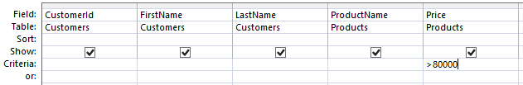
- Click the Run button in the Ribbon to view the results of the query. Alternatively, you can just click the Datasheet View icon. And here are the results:
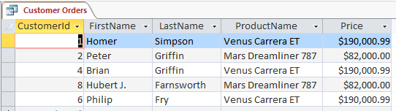

So as you can see, queries can be very powerful. Imagine what you could do if you had more tables (and data) in your database.
Just make sure your query names are descriptive of what the query is doing. Otherwise you might find it difficult to distinguish between queries once you have a good number of queries within your database.

1.9 Assignment for laboratory work

- Create a database with the same three tables.
- Fill in the table with their own data.
- Create relationships between tables.
- Create three different query.
- Make a report that contains a table in Design view and Datasheet view, relationships, query in Design view and Datasheet view.
- Respond to teacher's questions.

1.10 Questions

- What does it mean a database?
- What does it mean a Microsoft Access?
- How to create a database in Microsoft Access?
- What types of View tables exist?
- What kind of add data to the table exist?
- How to make the relationships between the tables?
- What are the different types of relationships exist?
- How to create a query?

